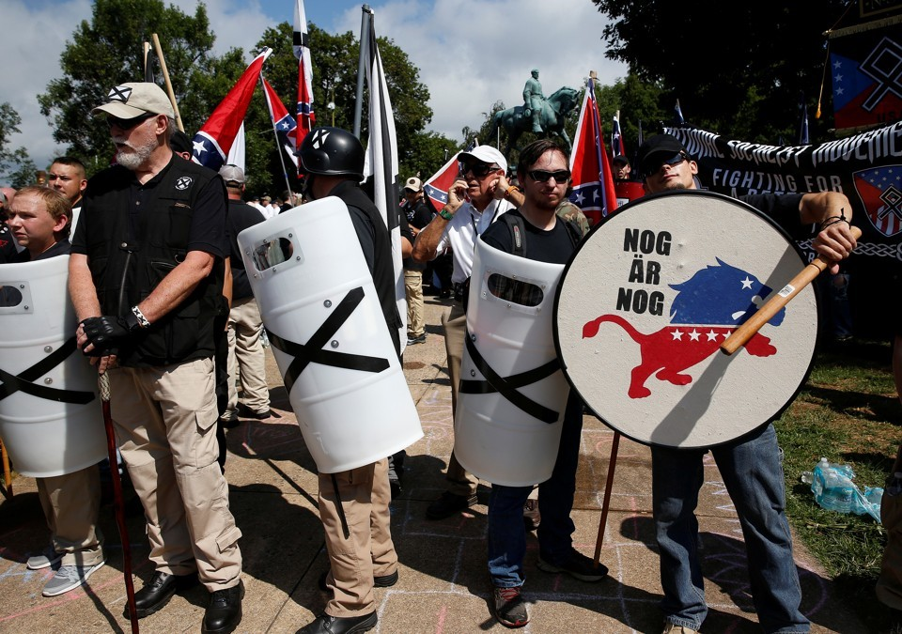
Joshua Roberts / Reuters
- MILA VERSTEEG

- 6:00 AM ET

This week on Radio Atlantic: Ta-Nehisi Coates and Yoni Appelbaum on Charlottesville's Aftermath. Listen and subscribe to the podcast.
Last Saturday, my adopted home was invaded by a throng of white nationalists—many heavily armed. They were opposed primarily by area residents, like myself. The results of that protest—the violence, injuries, and death—are by now well known.
I have called Charlottesville home for six years. When I got an offer to join the faculty of the University of Virginia Law School, I was hesitant to leave my native country, the Netherlands, to move to a small town in the American South. But I am glad I did; Charlottesville has been a wonderful place to live: a friendly, cosmopolitan, and welcoming college town.
As images of armed militias and others waving and wearing swastikas made their way across the globe, many of my European friends and family messaged me to ask why the government was allowing this to happen. After all, events would not have unfolded as they did if Charlottesville were in my native country, or for that matter, in any European country. Europeans reject and criminalize certain types of expression they define as hate speech. Much of the speech that we witnessed in Charlottesville would have qualified as such.
This trans-Atlantic difference is largely the product of Europe’s own history with Nazism. Many Europeans share complicated histories of Nazism that current generations are still grappling with. My own family history illustrates this.
On the eve of WWII, my working-class great-grandparents, like a large number of Dutch, joined the National Socialist Movement (NSB), a Nazi-aligned Dutch party. My family was poor, and joining the NSB improved my great-grandfather’s prospects for getting a factory job. Those who knew them insist that anti-Semitism did not motivate their decision to join the party. Still, they gradually started to buy into the party’s sinister ideology. After the war my great-grandparents were imprisoned for their NSB affiliation.
My grandfather made a different choice from his parents: during the German occupation he joined the Dutch resistance. He was soon arrested and sent to a labor camp in Germany. He escaped the camp and ended up between enemy lines, where German soldiers executed his travel companions but spared him because of his blond hair and blue eyes. A German mayor helped him after he escaped the labor camp. After the war, he traveled back from Russia to the Netherlands with a girl named Stella who had survived Auschwitz but died giving birth to her first child. These stories were revealed to us in bits and pieces. My grandfather was an amateur poet and prolific writer, but the memories remained raw and painful, and it took him six decades to finally tell his story in a (still unpublished) book.
One ordinary working-class family ended up on different sides of one of the worst atrocities in human history. Our family never overcame those divides.
After WWII, western Europeans—and decades later joined by their eastern compatriots—built one of the strongest human-rights systems in the world. Within the framework of the Council of Europe they adopted the European Convention of Human Rights, which would be enforced by both national courts and the newly established European Court of Human Rights. This system protects free speech— to an extent. European free-speech doctrine is based on the idea that free speech is important but not absolute, and must be balanced against other important values, such as human dignity.
As a result, freedom of expression can be restricted proportionally when it serves to “spread, incite, promote or justify hatred based on intolerance.” The International Covenant on Civil and Political Rights, an international human rights treaty, reflects similar principles. This balancing of free speech against other values led Germany to ban parties with Nazi ideologies and recently, to prosecute Chinese tourists who performed a Hitler salute in front of the Reichstag. It led France to outlaw the sale of Nazi paraphernalia on eBay, led Austria to jail a discredited historian who denies the holocaust, and caused the Netherlands to criminalize the selling of Mein Kampf. It is for this same reason that many Europeans could not believe the open display of swastika flags in Charlottesville.
Since WWII, the United States has taken a different tack, exceptional from a global perspective. American free-speech doctrine protects a panoply of viewpoints, even when they target ethnic or religious groups, cause deep offense, or are false by consensus. One underlying theory for doing so is that bad ideas will eventually lose out in a well-functioning marketplace. Some go so far as to argue that it is valuable in itself for a society to tolerate even the most extreme viewpoints. Hence, speech can almost never be restricted on the basis of viewpoint. Most famously, that approach protected the rights of neo-Nazis to march through heavily Jewish parts of Skokie in a 1977 Supreme Court case. It is the approach that allowed neo-Nazis and other white supremacists to demonstrate in Charlottesville on Saturday.
Whatever its merits, the European position is rooted in its experiences that the free market of ideas can fail—disastrously.
Americans are generally proud of their free speech tradition, and many argue that the European approach is unprincipled or ineffective. Why is denying the Holocaust forbidden, but depicting the prophet Muhammed—which is blasphemous to many Muslims—condoned? Many of these lines reflect majority opinion and national experience rather than neutral principles. And policing speech can embolden those being censored. When the far-right Dutch politician Geert Wilders was convicted for inciting discrimination, he became even more popular among some groups.
Whatever its merits, the European position is rooted in its experiences that the free market of ideas can fail—disastrously. Dangerous ideas can catch on quickly, especially when people holding power or influence endorse them. My great-grandparents were not like the protestors in Charlottesville last weekend; they were ordinary citizens who saw their economic lot improve and stayed silent because they benefited from, what some knew then—and nearly everyone knows now—were toxic ideas.
America today is different from Europe in the 1940s. But Europe’s history raises the question: Can we count on the market of ideas to succeed? Is it possible for white supremacy and related ideologies to spread beyond the relatively small number of Unite-the-Right fanatics and their brethren? Some suggest that Donald Trump’s election is one piece of evidence that’s it’s already happened.
There are no easy answer to these questions. But I believe that in a system where government does not police vile ideas, as in the United States, a larger burden falls on ordinary citizens and other private actors. It is my (admittedly anecdotal) observation that, to some extent, Americans are already doing this. Americans who express objectionable views face harsher community judgement than Europeans who do so.
My American fiancée has often expressed shock that the Dutch still commonly use the term neger (negro) although its usage is increasingly controversial. A team of all-black-faced helpers officially accompany the Dutch Santa before Christmas each year. And I have occasionally found myself surprised to learn that there are some things that I absolutely cannot say here, or that people can lose their jobs for what they say off-hours.
Americans long have been caught up in debates over whether there is too much political correctness. Though they are starting to emerge, there are many fewer such debates in Europe. To some extent that is understandable; when the government polices speech, ordinary citizens do not have to concern themselves with all the subtle ramifications of speech. What we may be seeing is a substitution effect: Ordinary citizens in the U.S. take it upon themselves to do what governments are doing elsewhere.
A minority of Americans believe that Donald Trump got elected in part because political correctness has gone too far. They believe that Trump is a healthy corrective in a society in which people are policing each other too much.
But the Charlottesville events, viewed through the lens of European history and its response in law, may teach us that we private citizens and residents in the U.S. need to work even harder to expose the rotten ideas being peddled in the marketplace. When leaders condone hate speech (as Trump’s condemnation of “both sides” and his insistence that the alt-right protestors included “some very fine people” arguably did) and ordinary people acquiesce, the market can break down quickly. European history has shown this. In an unregulated marketplace of ideas, private citizens need to take up the burden of holding the line against racist extremism.

Kevin Cope, University of Virginia School of Law and Department of Politics, contributed to this article.

